**UX/CX Study**

**Expense Tracker**

**About App**

Expense Tracker **[Expenso]** is a powerful tracking app for managing your personal finance planning, categorizing transactions, setting budgets, and generating reports. It gives you a way that automatically analyzes your income and expenses and saves accordingly.

**User Problem**

We have observed that people find very difficult to deal with the Numbers. They do not track their expenses in relation to their income.

**Problem Solution**

This app makes it easier for the user to review his financial health and gives the user his budget management system where user can set his own budget.

Users can categorize the overall monthly budget. Auto, Bank, Cash, Charity, Eating and Gift.

**Competitor Analysis**

We used competitor analysis to determine competitors’ strengths and weaknesses, as well as evaluate the UX/UI design elements of competitor products.

By doing so, we can generate more ideas to create a more user-friendly design that sets our product apart from the competition.

**Summary**

Strategic technique used to evaluate outside competitors. The analysis seeks to identify weaknesses and strengths that a company's competitors.

The strengths that the 3 apps have in common include user-friendly interfaces, expense tracking capabilities, budget customization, syncing with financial accounts and goal setting features.

One of the few weaknesses they have in common related to user interface is the learning curve for users who are new to budgeting software.

These Apps take too many customers data point like PAN, Aadhaar, Address and official and personal Email, and many more other details. I think they are distracting users from the main function.

**Step 1:**

**Customer analysis and User Research :**

**Primary Questions**

* Basic Details of the Applicant
* When did you start budgeting and why?
* What money goals do you want to reach?
* How budgeting improves your personal finances?
* What do you think are budgeting mistakes?
* What will make budgeting more interesting and enjoyable for you?
* Are you using the Expense Management App ?
* Which App do you like the most ?
* Any Challenge you are facing while using that App?
* Any Feedback or suggestion

**Major Insights**

* People track their spending by creating different categories.
* The best way to display a budget is using graphs.
* Setting the goal visually makes most people stay motivated.
* Collecting their experience

**Affinity Diagram**

Brainstormed and organized information for the user research.

**User Personas**

Based on the results of affinity mapping, we found groups of people that shared similar pain points, motivations, and goals.

**Pain Points and Solutions**

Bridging the gap between pain points to ideas

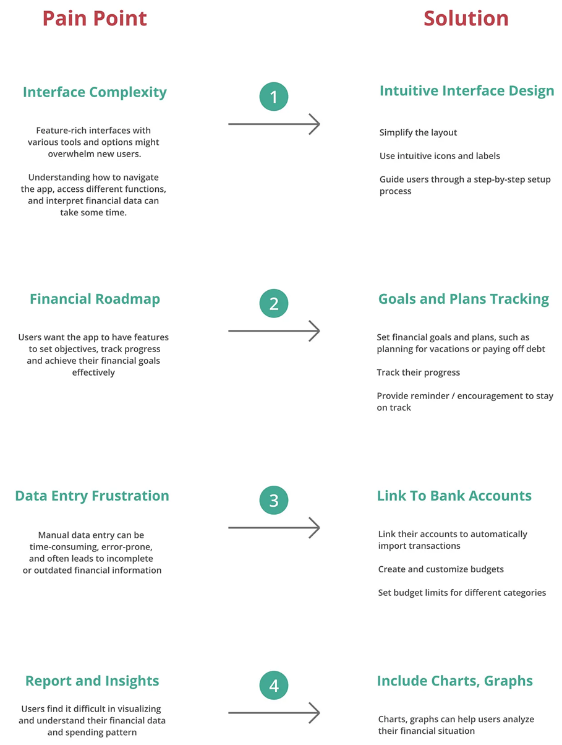

**Product structure and strategy**

**Step 2: Design Process**

**Paper Sketch**

Sketching out the main pages of the app based on the insights after conducting user research. This helps to have a more organic and free-flowing exploration of design ideas.

The app has main pages, which are login ,Create account, Daily Transaction ,Status with Reports, Budget, and Profile pages. Also sketching how to set up a new account and budget.

**Digital wireframes**

Then , it was converted to digital wireframes to create a detailed, interactive, and shareable representation of user interfaces, enabling better visualization and testing.

**Low-fidelity Prototype**

Creating low-fidelity prototype to quickly explore design concepts, prioritize functionality and layout, and gather early user feedback.

**Usability Study**

After that gathering feedback from users to identify usability issues, hence making informed design improvements.

**Findings**

* Users want to see the history of expenses that they made.
* After creating a budget plan, users also want to track their savings toward that budget.
* Users want to make planning a budget more engaging and enjoyable.

**Digital Wireframes**

Changes made to the digital wireframes based on the findings of the usability study.

**Step 3: Defining the design and Coordination with UI designer.**

**Style guide:**

To maintain visual consistency and ensure a cohesive and user-friendly experience across all interfaces and interactions.

**The blue and white color scheme** is clean, calming, and generally considered appropriate for finance apps .It can evoke a sense of security and growth.

**The font** appears clear and readable.

**Step 4: Going forward.**

the following skills:

* Problem statement: Clearly define the problem or challenge the budget app aims to address.
* User Research & User Testing: personas, user interviews, surveys, usability study
* Wireframes and Prototypes: Showcase low-fidelity wireframes and high-fidelity interactive prototypes.
* Visual Design: Display the app’s visual design, including color schemes, typography, and iconography.

also learning about the importance of iterative user testing and incorporating user feedback throughout the design process. This step is important since it ensures that the app effectively addresses user needs and provides a user-friendly experience.

Our Expense Tracker **Expenso** App Analysis:

|  |  |
| --- | --- |
| **Onboarding Page:**   * **Clear Focus:** Simple Interface has a clear purpose to allow users to access their accounts to avoid overwhelming users. * **Centered Logo:** The centered logo reinforces the brand and adds visual balance to the screen. | **Create Account Page:**   * This page allows new users to register for the app. * Clear labels guide users through the signup process. |
| User can choose a picture from gallery. | and also crop the image to be as wanted. |
| **Creating an account** | **Forgot password feature:**  (note the email used was not real with domain applicable but tested with real email) |
| **Login Page:**   * This page enables existing users to log in to their account. * Clear labels and buttons guide users through the login process.    | **Daily Transactions Page:**   * This page displays a list of the user's daily expenses with categories. * A screenshot of a phone    Description automatically generatedFocuses on essential transaction details. |
| **Create New Budget Page:**   * If you haven't already, start by creating a new budget. This involves naming the budget and setting a timeframe (e.g., monthly budget). * **Set Budget Amounts:** For each category . This determines how much you plan to spend in each. | **Budget Page:**   * This page allows users to create and manage their budget. * Clear presentation of budget summary and spending categories.    |
| Animation couldn’t be shown here.   |  |
| Notification generated from firebase cloud messaging.  Note that other feature like the currency symbol is chose from the locale of the device so a pound currency was used (English UK). |  |
| **Status Page:**   * Displays the total payment amount (for the day). * **Pie Chart:** Shows daily expenses grouped by category. * **Timeline:** Presents a horizontal timeline with transaction bars indicating daily value.   A screenshot of a graph  Description automatically generated | **Profile Page:**   * This page displays the user's profile information. * **Clarity of Information:** The profile information (email, date of birth, bio) is clearly displayed.    |

**CX (Customer Experience):**

* **Focuses on the broader customer journey, encompassing all touchpoints.** This includes:
  + **Onboarding experience:** How easy is it for users to set up and start using the app?
  + **Customer support:** How easy is it for users to get help if they have questions or problems?
  + **purpose perception:** Does the app create a positive overall impression of the purpose behind it?
  + **Loyalty and advocacy:** Does the app encourage users to become loyal users and recommend it to others?

**How UX and CX work together in our app:**

* A well-designed app (good UX) will make it easier for users to track their finances, which can lead to a more positive experience and customer loyalty (good CX).
* A positive customer experience (CX) can encourage users to continue using the app and recommend it to others, even if the app itself has some minor usability challenges.

**UX Study:**

* **User testing:** Observe users interacting with the app and identify any usability issues.
* **Heuristic evaluation:** Evaluate the app against established usability principles .
* **User surveys:** Ask users about their experience with the app and what could be improved.

**CX Study:**

* **Customer interviews:** Talk to users about their overall experience with the app, including their pain points and goals.
* **App store reviews:** Analyze reviews left by users to identify common themes and areas for improvement.
* **Customer service data:** Look at data from customer support inquiries to identify common issues and opportunities for improvement.

By considering both UX and CX, an expense tracker app would meet the needs of your users and creates a positive overall experience.